Written Lab 9: Lab on Security

Key Networking Terms:

1. Access list ranges
   1. Standard : 1-99, 1300-1999
   2. Extended: 100-199, 2000-2699
   3. The numbers one uses to configure access lists.
2. Remark
   1. Essentially, a comment/description for ACLs. This can help an administrator understand the purpose of an ACL without having to delve deeply into what is going on.
3. Access Lists
   1. The way of handling traffic across a network. Access lists filter traffic going into or out of a network. Access lists are created and the applied to routers.
   2. Standard access lists are more general and only filter by source IP.
   3. Extended access lists can be more specific and filter by type, port number, source IP, and destination IP.

Procedures:

1. Lab Simulation #1
   1. Access Control Lists ACL
   2. Starting configuration:

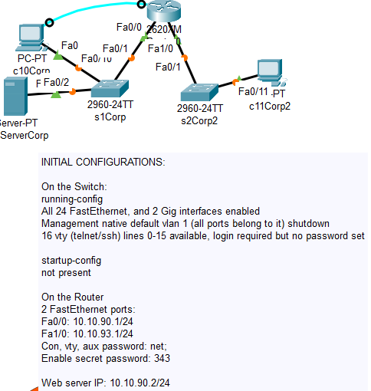

* 1. Lab Procedures:
     1. Verify ping from c10 and c11 to weServerCorp.
     2. Block c11 from accessing webServer by named ACL

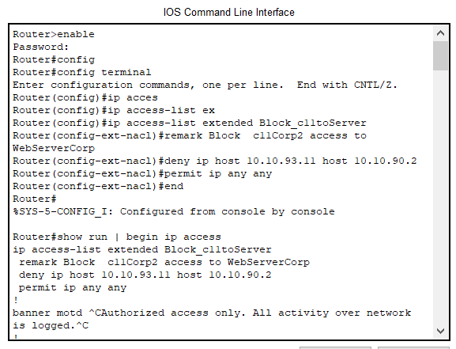

* + 1. Make sure c11 webServer cannot ping but c10 can.

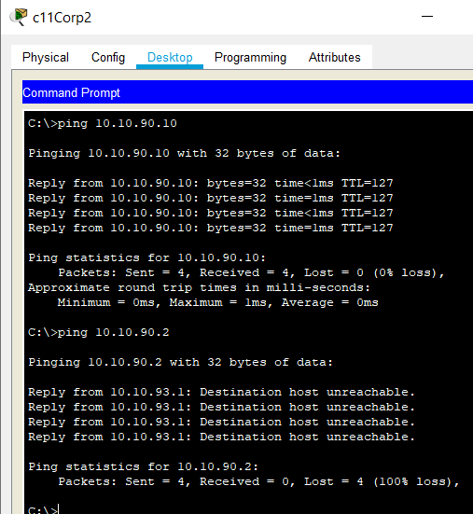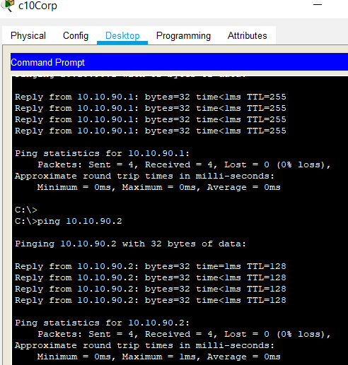

1. Lab Simulation #3
   1. Extended ACLs
   2. Starting configuration:

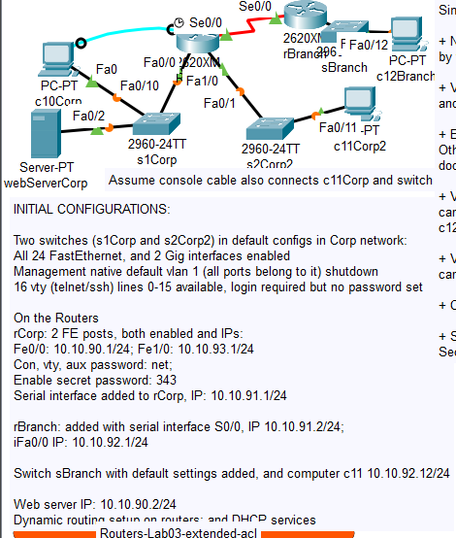

* 1. Lab Procedures:
     1. Verify pings to webserver
     2. Block c12Branch access to **http** services only webserver

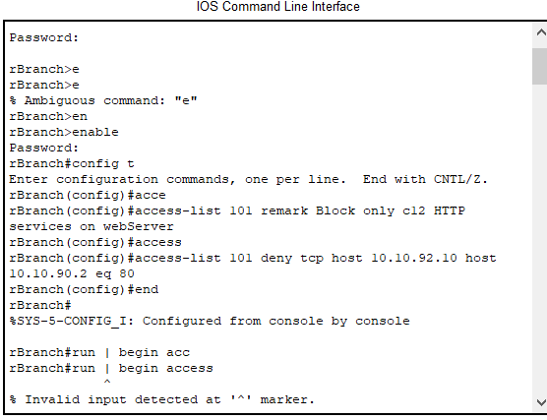

Forgot a line, so I had to add it later

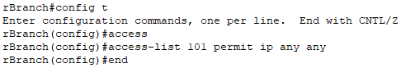

* + 1. Verify pings and blocks

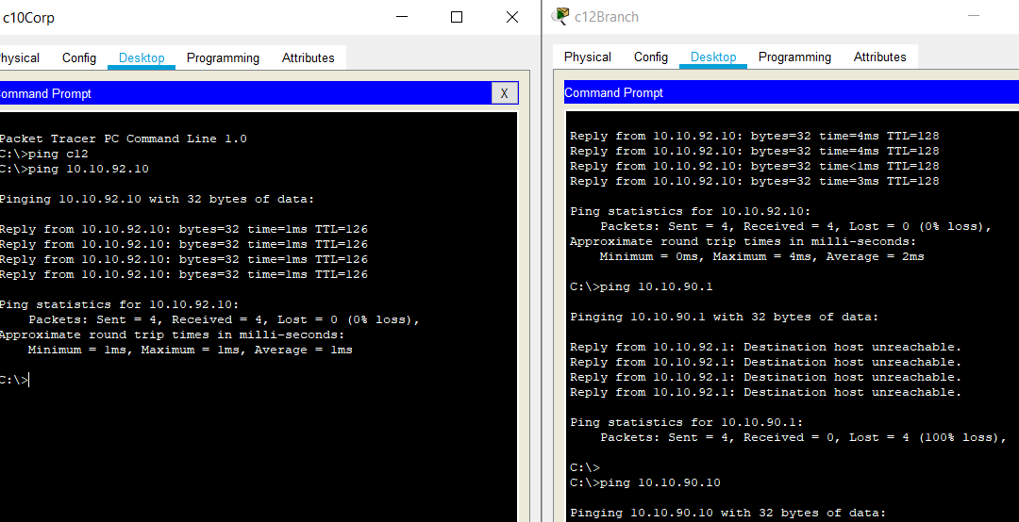

Conclusions and Discussion:

The chapter 12 readings were pretty interesting; I wondered how firewalls worked and now I know partly how they do. I was surprised that the only big topic here was access lists, but I guess that stresses their importance to network security. I am still partly curious as to why the access list numbers are they way they are, in terms of extended and standard number ranges. Although, besides that quality, ACLs have made a lot of sense to me, its like you are making a permission list for those traveling inside and outside of a country; who can go where and by what means. This chapter found pretty relaxing even if I made a few silly blunders while coding in the information. One thing that bothers is the inefficient way to see what access list is applied to each interface; the answer seems to have been lost in a mass of text. However, I am sure there are some tricks I am missing that I will learn as I continue my networking journey.

Feedback:

NA- submitted day portfolio was due